HW3 Yuan Qin

[Yqin7@uci.edu](mailto:Yqin7@uci.edu)

1.(b) Different as we can see from the following graph.

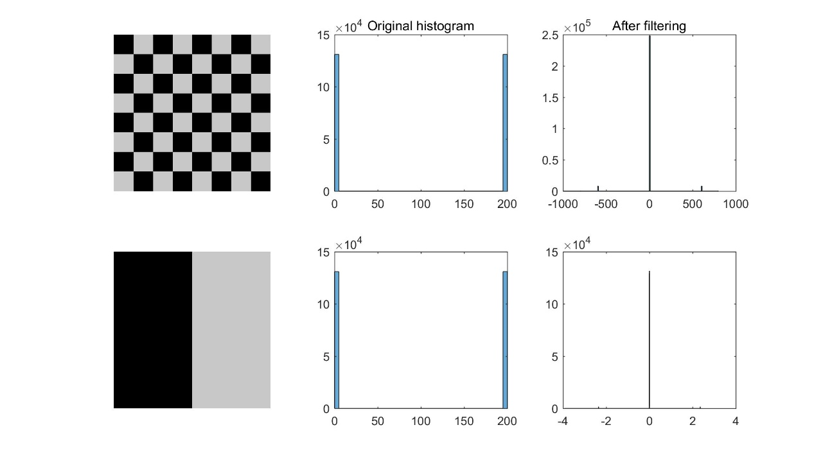

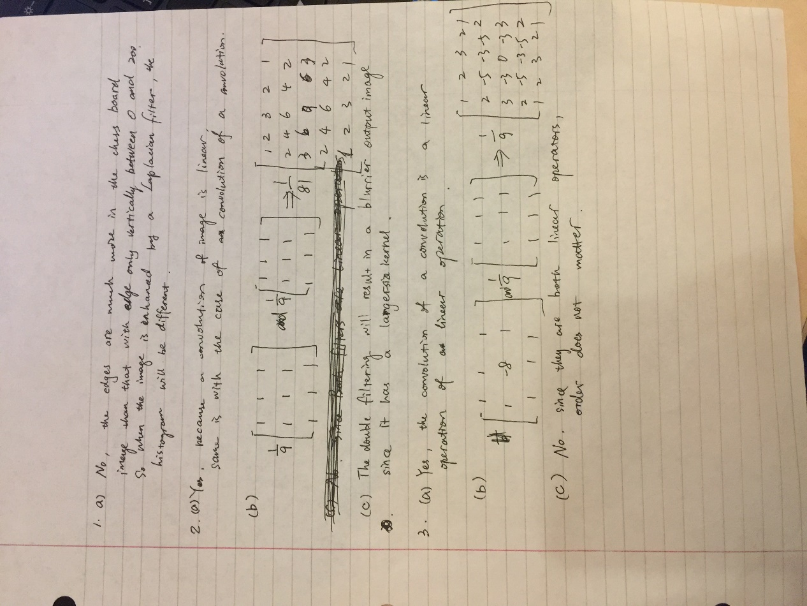

Computer problem:

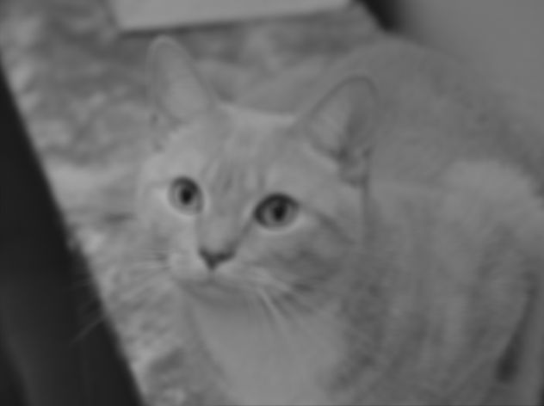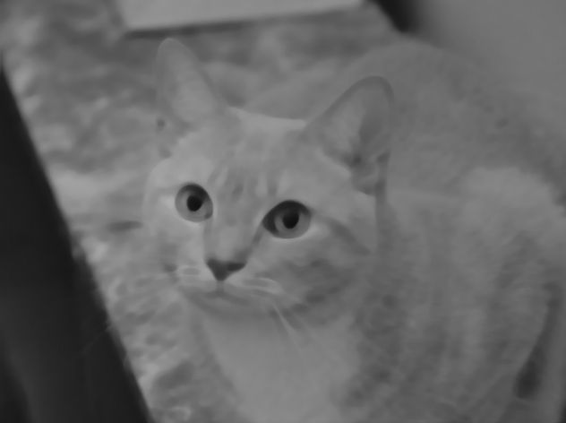

9x9 Averaging filter 9x9 Median filter

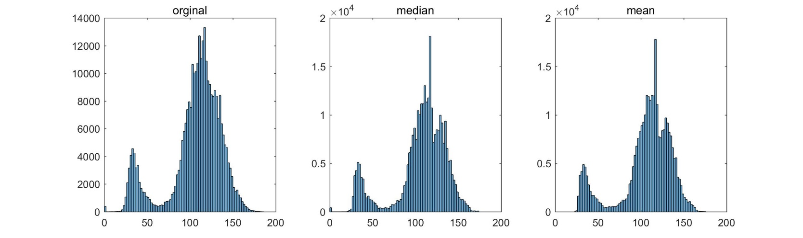

Histogram of cat

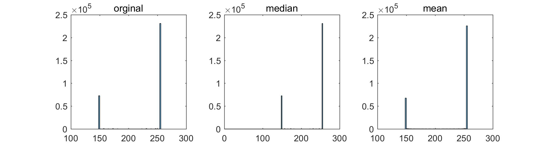

Histogram of triangle